Experiment 1: Titration of Amino Acids

Theoretical Background
Proteins are large molecules found in the cells of living organisms and in biological fluids. They play crucial roles in virtually all biological processes. The major functions of proteins can be summarized as: enzymatic catalysis, control of growth and differentiation, transport and storage, coordinated motion, mechanical support [1]. Some proteins are globular and water soluble, like those found in blood, milk, and egg white. Others are fibrous and relatively inert. Keratins are proteins found in hair and wool, and collagens are the proteins found in connective tissues such as tendons. Proteins have molecular weights ranging from five thousand to several million atomic units [2].

Proteins can be considered as condensation polymers, which are composed of 20 different α – amino acids [2]. An α – amino acid consists of an amino group, a carboxyl group, a hydrogen atom and a distinctive R group, all of which bind to an α – carbon atom. This carbon atom is named as α because it is adjacent to the carboxyl (acidic) group.

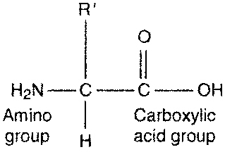

Figure 1: Unionized form of an amino acid [3]

20 kinds of R groups varying in size, shape, charge, hydrogen-bonding activity, and chemical reactivity are commonly found in proteins. Indeed, all proteins in all species, from bacteria to human, are constructed from the same set of amino acids [1].

A reaction between two amino acids occurs between the carboxyl group of one amino acid and the amine group of another amoino acid, with the elimination of water molecule and the formation of an amide bond. The amide bond that connects two amino acids is called “peptide bond”. When two or more amino acids are connected by a peptide bond, the resulting molecule is referred as peptide [2].

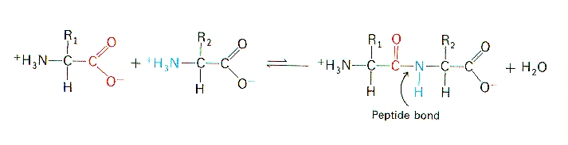

Figure 2: Peptide bond formation [4]

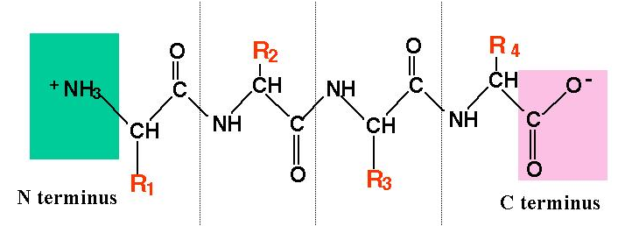

Figure 3: Simplified polypeptide structure [5]

Dipeptides still have a free amine group at one end and a free carboxyl group at the other end of the molecule. Additional amino acids may continue the condensation reactions to form larger peptides [2]. A polypeptide chain consists of a regularly repeating part, the main chain, and a variable part, the side chain.

Amino acids in solution at neutral pH are predominantly dipolar ions, or zwitterions, rather than un-ionized molecules. The point at which the zwitterions formed is called the isoelectric point (pI) of an amino acid. At the isoelectric point, the amine group shows a positive charge and the carboxyl group has a negative charge, therefore, the overall zwitterionic form is neutral. Thus, the zwitterionic form is the least soluble in water.

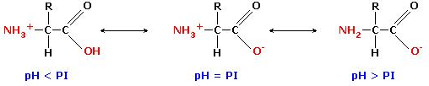

Figure 4: The zwitterionic form of an amino acid at different pH values [6]

In acidic solution, (e.g. pH = 3.0), the carboxyl group is unionized (-COOH) and the amino group is ionized (-NH₃⁺). Whereas, in an alkaline solution, (e.g. pH = 9.0), the carboxyl group is ionized (-COO⁻) and the amino group is unionized (-NH₂) [1].

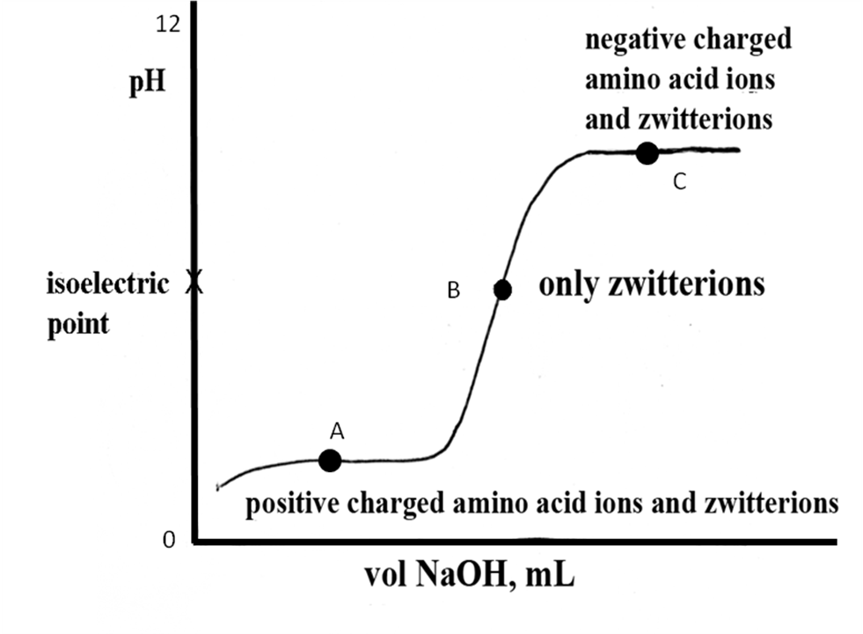
Figure 5: Titration curve for an amino acid [7]

The pKa, or dissociation constant is a measure of the strength of an acid or a base. It is the pH at which one-half of the acid present has reacted with the base. When the curve reaches the first of two flat regions, labeled A in Figure 5, the point where one-half of the carboxyl group is deprotonated is reached. At the point of inflection, point B, the carboxyl group is completely deprotonated and the isoelectric point is reached. At this point the amino acid exists in zwitterionic form. At the second of two flat regions, labeled as point C, one-half of the amine group is protonated. The isoelectric point of an amino acid can be calculated according to the following equation:

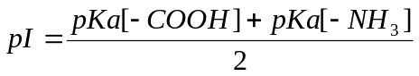 (1)

This equation can be used only for amino acids that do not carry acidic or basic groups in their side chains [2].

Apparatus
Equipment Chemicals
Beakers, 100 mL *2 Glycine, CHNH₃COOH
Droppers Sodium hydroxide, NaOH
Burette 50 mL Hydrochloric acid, HCl
Stand
Clamps
Funnel
Magnetic Stirrer

Procedure
- Prepare the glycine and NaOH solutions in 100 mL beakers.
- Add 1M HCl solution to the glycine solution dropwise while stirring until the solution’s pH reaches 1.5. Always control the pH of the solution with the pHmeter.
- Rinse the burette with 5 mL NaOH solution you prepared.
- Fill the burette, by using a funnel, with NaOH solution ( be sure the tip of the burette is also filled with NaOH solution).
- Place the beaker containing amino acid solution (pH 1.5) under the burette and immerse electrode in the beaker.
- Add NaOH solution in 1 mL increments, record the pH of solution after each 1 mL addition of NaOH solution ( When the pH of the solution starts to differ in high quantities, decrease the amount of NaOH solution you add, 0.5 mL for example).
- Continue adding 1 mL NaOH solution until the pH of solution becomes 12.

Calculations
- Construct the titration curve, by plotting pH of the solution versus volume of NaOH added.
- From the titration curve, determine the pKa of the carboxyl group and the amine groups, calculate the isoelectric point (pI) of glycine.

Report Objectives
- Draw the structure of zwitterionic forms of glycine and the amino acid you are assigned and draw dipeptide structure of these two amino acids.
- Calculate the isoelectric point of glycine by using Equation 1.
- Search fort he pKa values of glycine and the amino acid you are assigned from other sources.
- Find the isoelectric values for aspartic acid ( aspartate) and arginine, discuss the difference of their pI values.

References
- Stryer, L., Biochemistry, 4th Edition, W.H. Freeman Company, New York, 1999.
- Stanton, B., Ruff, J., Experiments in General, Organic and Biological Chemistry, 1995.
- http://www.answers.com/topic/amino-acid
- http://cmgm.stanford.edu/biochem/biochem201/Slides/Protein%20Structure/Peptide%20Bond%20Formation.jpg
- http://www.ucl.ac.uk/~sjjgsca/peptide1.gif
- http://www.azaquar.com/en/doc/proteins-peptides-and-amino-acids
- http://homepages.ius.edu/DSPURLOC/c122/amino.htm

